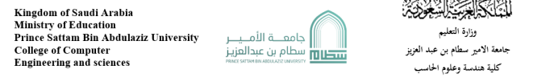



Sehhaty app



443051124

Abdullah Alsheddi

Supervised by: Dr. mohammed Asiri

Year:2023

**Group Project Proposal:**

Introduction:

Health is of great importance in human life, and achieving and achieving goals requires a healthy person who is able to face anything that stands in his way. Just as physical health is important to mental health, vitamins are also among the most important causes of mental health. That is why there should be an application to help you maintain health and receive reports about your body on your phone.

The Problems :

Most people don't want to go to the hospital for a simple reason, many people don't want to go to book an appointment with the doctor because sometimes they are busy or the hospital is far away from him.

Background:

Sehhaty is an electronic platform of health services for individuals in Saudi Arabia. Sehhaty aims to enable users to reach health information and medical e-services provided by different health organization.

Proposed solution:

Sehhaty app came with the option to take a appointments with different doctors in different hospitals.

Work plan:

If I was the programmer of the app I would add more choices for the user such as a video call or a chat for the appointment , and a list contain your appointments with a report for each one , also a notification with a healthy advice every day.

**Projact requiermants:**

Functional requierments:

**Login** – the user shall login into the app by write his id and password

**Notifications** - the system shall inform the customer before his appoiment or when he recive a report from his doctor.

**Search** –the asystem shall allow the user to search in search box for a section or a specific doctor by his name .

**Doctor info** – the system shall show the info of doctor for patients.

**Sections** – the system shall allow the user to section that he want.

**Appointments reports –** the system shall allow the doctor to sent the reports to the user

**Database** – system database shall contain all info about users.

**Chat** – the system shall contain a chat between the patients and the doctor for answer his question.

Non-Functional requierments:

**Availability** – app availability 27/4

**Security** – the app should keep the information safe and log out the user auto.

**Usability** – ease of use .

**Accessability** – the app should have many languages .

**Activity digram:**

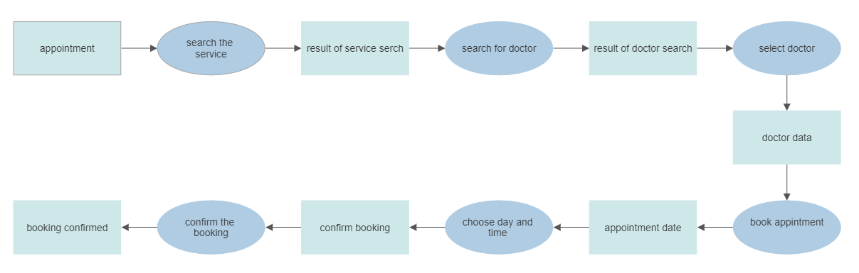

**Project use case modeling:**

Actors: patient – doctors –appointments manegars in hospitals

Use case:

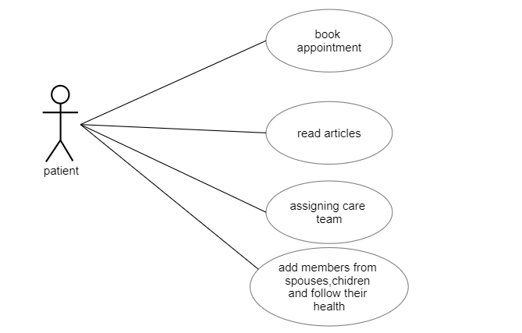

Table 1: assigning care team

|  |  |
| --- | --- |
| Actors | Patient - doctor |
| description | The paitient can choose a care team to assign them to take care of him. |
| Data | Paitient information – and the team membars information |
| stimulus | The patient ask to aassign care teame |
| response | The care teame has been assigned |
| Comments | The seats in the team care are limited the patient can't assign a team if there is no available seat |

Table 2 :

Book appointment

|  |  |
| --- | --- |
| actors | Patient - appointments manegars in hospitals - doctor |
| description | The patient can book appointments in the app but sometimes the time of the appointment is not appropriate time for the doctor so the appointments manegars in hospitals are responsible for organizing appointments to be appropriate for the doctor |
| Data | Patient information – doctor appointments |
| stimulus | The patient book an appointments with a doctor |
| response | The appointments has been booked |
| comment | The patient can cancel the appointment before 24h from it |

**Sequence Diagrams:**

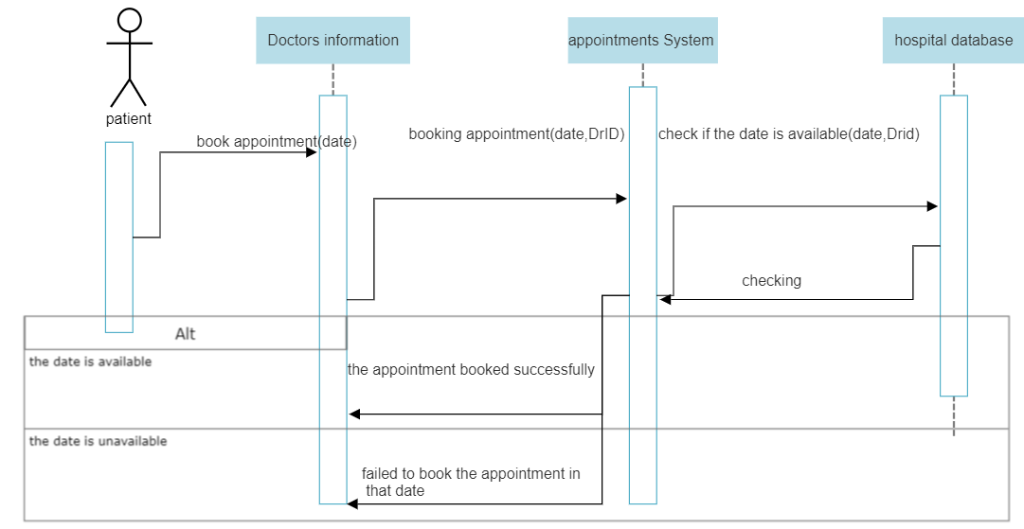

**Class digram:**

